[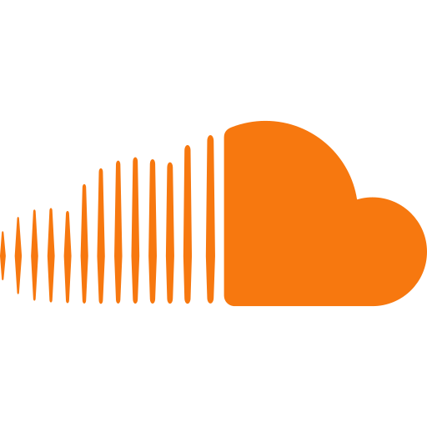](https://soundcloud.com/)SOUNDCLOUD

Database Analysis

**SoundCloud**

SoundCloud is a music streaming service that allows users to upload, share, and promote audio. It is one of the world's largest music streaming services, with over 400 million tracks from more than 40 million artists.

**Objective**

Creating a database driven system using Structured Query Language for improving customer experience and boosting contribution to the music industry by providing relevant and timely metrics. The sole purpose of this data analysis is to facilitate good use case for the users of SoundCloud and make SoundCloud a renowned music service provider.

**How is this useful?**

The project provides a comprehensive solution for managing the ever-increasing amount of data in the app, benefiting both the consumers and the administrators. The suggestions provided at the end of the project and the insights produced by the queries help in improving the consumer experience as well as Music industry insights.

**Tools and Database used:**

* SQL: DDL, DML, DQL
* Database Management System: PostgreSQL.

Dataset and Database: [SoundCloud Analysis.sql](https://1drv.ms/u/c/a966ac383646d63f/EXSiNsslOCNGn8qLHnELpL4BgdvsWXbkNEZ8my7zP1Fl2g?e=Cxe3Pw)

**Tables and Relations**

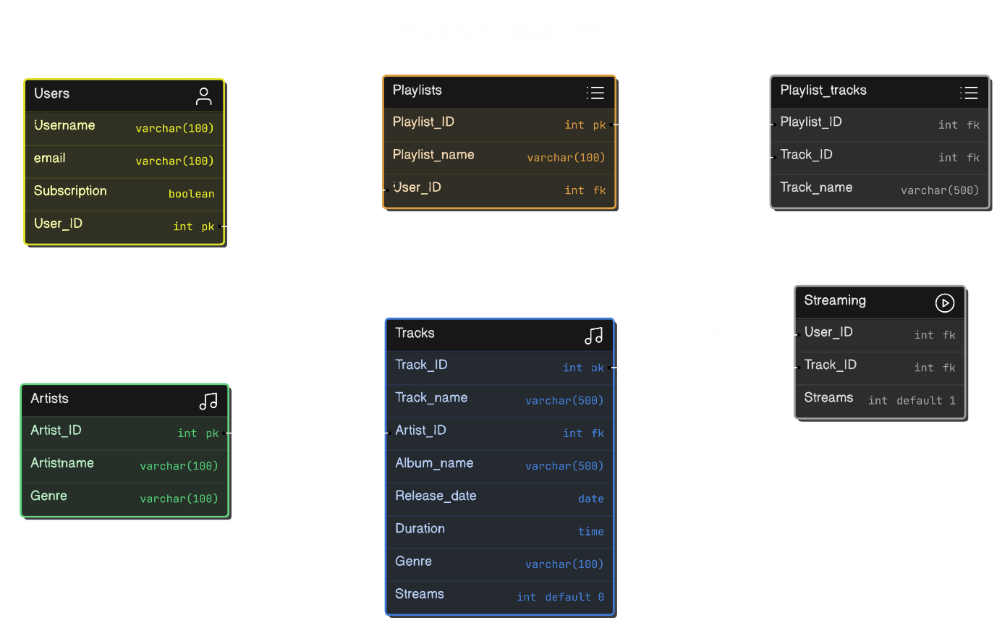

**Data Analysis**

1. Querying the names of people who do not use Premium can be used to keep track of users that need to be provided with mails suggesting yearly plans and various seasonal discounts. People using mail with different mailing services like Gmail and Hotmail can be given respective discounts.
2. Querying total streams of specific songs can generate data that can be provided to Billboard charts. This analysis leads to the global market standing of that song.
3. Queries like the no. of playlists made by all users and songs streamed by every user help in tracking user activity and the interest of every user. Gaining streaming behavior insights also contributes to Machine Learning algorithms for suggesting similar songs to the users and keeping users engaged on the app.
4. Querying the most streamed artist(s) can help incentivize artists on the platform. This data is also useful for the Music industry as it contributes to the Billboard charts.
5. Querying the most streamed song by each user gives the data that can be used in providing yearly wrap ups like the ‘Spotify Wrapped’ provided by Spotify at the end of every year. This data also helps in engaging the users and helps the app algorithm in hindsight.
6. Queries that return data to identify users who streamed the most streamed artists and most listened genre help in producing interactive elements in the yearly wraps, as mentioned earlier, and most listened genre helps in identifying trends which again help in improving the algorithm.
7. Lastly, querying the listening habits of every user and viewing songs by genre help in identifying user activity and keeping record of genres.

**Conclusion and Insights**

The project aims at providing an engaging and smooth user experience to the app by leveraging data obtained.

By implementing the suggested additions and metrics, users can have an end-to-end smooth listening and streaming experience. By utilizing aggregate functions, joins, and subqueries, we can gain insights into the total streams of artists, most-streamed songs by users, and popular genres. These insights provide valuable information for enhancing user experience, personalizing recommendations, and improving content curation strategies for the music streaming service.